**Puzzler game template**

Modulette ID:

Game #:

Game title: Puzzler

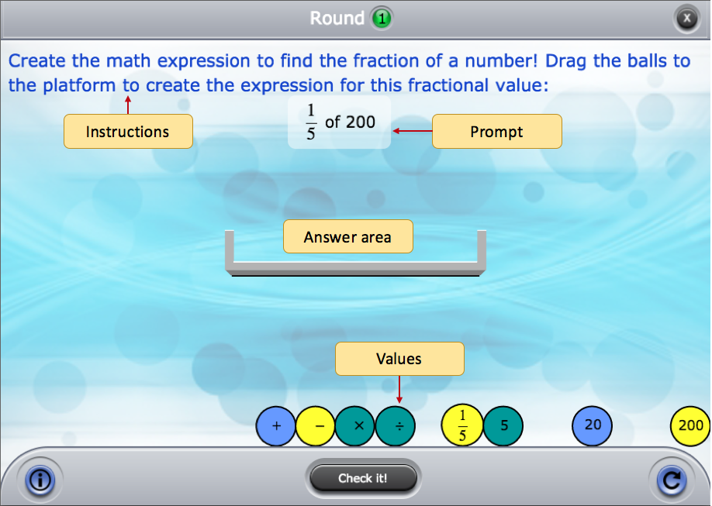

Instructions: [Use if instructions are the same for every round]

Round #

**Instructions:** [Use if the instructions are round specific]

**Correct feedback:** [Message to display when answered correctly]

**General incorrect Feedback:** [Message to display when answered incorrectly]

|  |  |  |
| --- | --- | --- |
| [All answer values, including distractors. Enter each value on its own row.] | [Correct answer] | [Alternate ways to build correct answer. Enter each answer on its own row] |

**Specific Incorrect Feedback table (May be more or less than 3):**

|  |  |
| --- | --- |
| [Incorrect answer configuration 1] | [Feedback] |
| [Incorrect answer configuration 2] | [Feedback] |
| [Incorrect answer configuration 3] | [Feedback] |